OGAM STEREO VISION DATASET
TECHNICAL REPORT

Rev. AA
Spring 2020

Prepared by: Hasan Atakan BEDEL, Mehmet Salih ARSLAN
Supervisors: Dr. Kutalmış Gokalp İNCE, Prof. Dr. A. Aydın ALATAN

- SCOPE OF PROJECT
This project aims to build-up a stereo-vision dataset for human-like robots. State-of-the-art deep neural networks need large amount of training data, therefore such a set should be generated without human interaction; in other words whole process should be automatic and large amount of ground-truth depth data should be easily collected. For these purposes two different sensors, Intel D435i and Intel T265 are employed. Specifications of those hardware are presented in Hardware section. Internal calibration, external calibration and time synchronization of hardware are explained in Calibration of Sensors section. Finally, in the last section a method to project the depth data of D435i onto T265 and to complete missing depth data on D430 is proposed.
- HARDWARE
  - D435i
Explain the employed hardware here, give details about the included sensors in D430 and T235 (imu, RGB camera, IR camera etc.), spatial and temporal resolution, field of view, imu data. Specify the coordinate system of depth output and imu data.

    - D435i Sensors
Icindeki sensorler, ozellikleri ve en son tablo olarak bir ozet
Intel realsense D435i is a depth sensing camera. It utilizes two infrared cameras and one RGB camera together with an IMU sensor and infrared projector. It can measure distances from 28 cm to 10 m. It calculates depth frame from two infrared frames which has FOV of 87°±3° x 58°±1° x 95°±3°. Resolution of the depth frame is 1270 x 720. D435i produces 30 depth frames per second via USB 3.1. Baseline of the sensor is 50 mm. Depth resolution is 1 mm. Spatial noise is less than 2%, temporal noise is less than 1% on depth data. IMU measures 3 axis acceleration and angular velocity. IMU data oriented such that x axis is towards right infrared camera, y axis is towards bottom and z axis towards out of the device when looked from the behind of the camera.
D435i has BMI055 as IMU sensor which has six degrees of freedom. Acceleration range is between ±4g. Sampling rate is 62.5 Hz. Gyroscope range is ±1000 deg/s. Sampling rate of the gyroscope is 200 Hz. Each data from IMU has a time stamp which is accurate up to 50 μs.
Infrared cameras are OmniVision OV9282 with resolution of 1280 x 800 and fixed focal length of 1.93 mm. Data format of the infrared frames are 10-bit RAW. Distortion of the sensors is less than 1.5%. FOV of the sensors is 91.2° x 65.5° x 100.6°.
RGB camera is Omnivision OV2740 which has resolution of 1920 x 1080 and fixed focal length of 1.88 mm. Data format of the RGB frame is 10-bit RAW RGB. Distortion of the sensor is less than 1.5%. FOV of the sensor is 69.4° x 42.5° x 77°.
Infrared projector projects a static infrared pattern to increase texture on the scene by this way accuracy is increased. Field of projection is 64°±3° x 41°±3° x 72°±3°.

    - D435i Device Data
Varsa Intelin verdigi calibration data (kameralar ve imu arasi transformation matrix) yoksa hangi koordinat sisteminde calistigi, time stamp vb.
Depth data is with respect to plane of the two infrared cameras. Origin of the depth data is the center of the left imager.
Rotation between infrared imagers is identity
Translation from right infrared imager to left infrared imager is [-0.049962237477303, 0, 0] : [x, y, z]
Rotation from RGB imager to left infrared imager is [-0.003309185151011, -0.000677197298501, -0.006368848029524, -0.999974012374878] : [x, y, z, w]
Translation from RGB imager to left infrared imager is [0.014851336367428, 0.0004623454588, 0.000593442469835] : [x, y, z]
Transformation from IMU to left imager is done internally by D435i. Thus, IMU data share the same coordinate system with the depth data.

  - T265

    - T265 Sensors
Intel realsense T265 is a tracking-camera. It utilizes two infrared fisheye cameras and an IMU sensor. Infrared camera sensors are OV9282. Baseline of the T265 is 64 mm. Imagers have 173° diagonal FOV. Camera resolution is 848 x 800. T265 uses the same IMU sensor with D435i. IMU’s acceleration sensor has sampling rate of 62.5 Hz whereas, gyroscope has 200 Hz. T265 estimates 6 degrees of freedom pose data at 200 Hz.
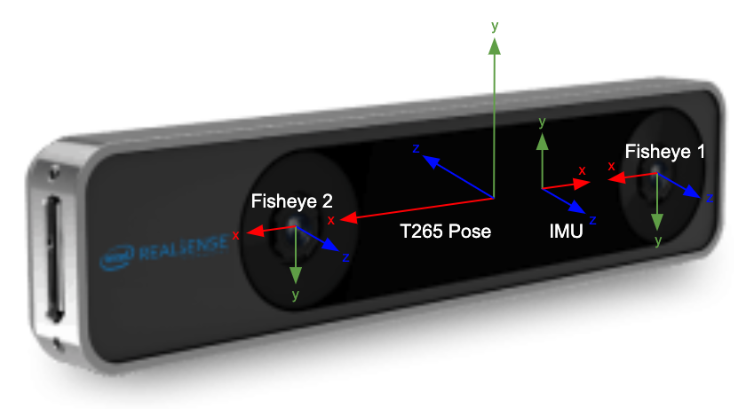Figure 1: Coordinate systems of T265 [3]

    - T265 Device Data
D430’da anlattiklarimiza ilave olarak, Kameralarin fisheye oldugundan, bu nedenle distortion parametrelerinin gerektiginden Intel’in bu parametreleri sagladigindan bahsedecegiz. Bu parametrelerin neye karsilik geldiginden, koordinatlarin nasil duzeltildiginden vb. Bahsedilecek, yani bu bolumu okuyan bir kisi Intel’in verdigi veriler ile gorunutunun nasil undstort edildigini anlamali. Camera matrixler ve iki kamera arasindadki transformation matrixten de bahsedilmeli. Bu matrixler kullanilarak bir kameradaki bir pikselin derinlik degeri biliniyorsa diger kameradaki hangi piksele dusecegi, derinlik degeri bilinmiyorsa epipolar line’in nasil bulunacagi anlatilmali.
Translation from fisheye 1 to pose is [0.031929191201925, 0.000113989575766, -3.38033132720739E-05] : [x, y, z]
Rotation from fisheye 1 to pose is [0.99998950958252, 0.003296238137409, -0.00291465758346, 0.001287228194997] : [x, y, z, w]
Translation from fisheye 2 to pose is [-0.031929302960634, 7.47319791116752E-05, -4.20763171860017E-05] : [x, y, z]
Rotation from fisheye 2 to pose is [0.999997079372406, 0.000338271434885, -0.001731238677166, 0.001662679249421] : [x, y, z, w]
Translation from IMU to pose is [-0.021229315549135, 2.60376800724771E-05, 9.00632439879701E-05] : [x, y, z]
Rotation from IMU to pose is [0, 1, 0, 0] : [x, y, z, w]
T265 has fisheye lenses on its cameras, therefore, obtained images are not planar. However, for our purposes we need planar images. In order to obtain planar images from distorted images we need to undistort the images. Intel provides distortion parameters considering Kannala-Brandt camera model. In other words, distortion parameters are the parameters of Kannala-Brandt model.
Distortion parameters of fisheye 1 are [-0.00012164260260760784, 0.03437558934092522, -0.03252582997083664, 0.004925379063934088, 0.0]
Kamera matrix of fisheye 1 is [284.501708984375, 0.0, 430.9294128417969, 0.0, 285.4164123535156, 394.66510009765625, 0.0, 0.0, 1.0]
Distortion parameters of fisheye 2 are [0.0009760634857229888, 0.030147459357976913, -0.02769969031214714, 0.0031066760420799255, 0.0]
Kamera matrix of fisheye 2 is [284.1828918457031, 0.0, 427.9779052734375, 0.0, 285.0440979003906, 399.5506896972656, 0.0, 0.0, 1.0]
When translation and rotation matrices are multiplied with points in one coordinate system the result is

- CALIBRATION OF SENSORS

  - Verification of T265 Internal Camera Parameters
Intel left ve right kameralar icin camera matrix ve distortion parametrelerini sagliyor. Ayni parametreler Caltech Calibration Toolbox ile de elde edilebiliyor. Intel’in verdigi distortion parametreleri ve bizim cozumumuz olan distortion parametreleri ile goruntu duzeltildiginde, goruntunun kenarlarina denk gelen koordinatlarda (distortion’in en fazla oldugu yerler) duzeltilmis koordinatlar arasindaki farkin 0.5 pixel’den kucuk oldugu teyit edilecek.

  - Verification of T265 External Camera Parameters
External parametreler transformation matrix [R | t] seklinde mi yoksa homogrpahy (H) olarak mi veriliyor? Gerci bize H lazim, o da camera matrix ve [R | t] ile elde edilir.

Bir kameradaki bir noktanin diger kameradaki esinin o epipolar line’a uzakligi ne kadar oluyor, intel ve bizim buldugumuz parametreler ile distortion duzeltildikten sonra?

  - Finding Transformation Matrix Between D435i and T265
Transformation between D430 RGB camera and T235 left and right cameras can be found with two alternative methods: as both sensors have IMU transformation matrix can be found using IMU data, as an alternative transformation matrix can be found using images with Calibration Toolbox.
    - IMU Method
Explain here
    - Visual Method
Explain here

  - Verification of Transformation Matrix between D435i and T265
D uzerinde tespit edilecek feature pointler icin 3D koordinatlar elde edilebilir, L ve R icin camera matrix, T_D^L ve T_D^R ile bu feature pointlerin L ve R uzerineki projection’lari elde edilir. Bu nokta civarinda tekrar feature point bulunarak reprojection error hesaplanabilir.
  - Time Synchronization
Explain here
- PROJECTING DEPTH DATA ON T265
- Using RGBD data of D435i obtain the 3D point cloud on D435i RGB camera coordinate system,
- Project this 3D point cloud onto T265 L and R cameras,
- Extract superpixels on T265 L and R cameras using intensity image (I),
- Fit a plane to each SP using projected depth data,
- Refine SPs using RGBDI data, if a pixel does not contain RGBD data find pixel to SP distance using I only, otherwise use all five channels,
- Now you have SPs on L and R images each modeled as a plane, if the base camera is L, when you project SPs on L to R you can find occlusions and if you project SPs on R to L you can find discclusions
- To verify the depth estimates, project them back to D435i and compute depth reprojection error
Using this approach a dense depth field for L and R cameras can be obtained
If this method fails to provide high quality data, SPs on L can be projected onto R and SPs can be refined using six channel RGBDLeftRight data for the pixel which are not occluded.
This method would probably fail on partially/fully reflective surfaces, shadows and transparent/semi transparent surfaces.

References
[1] https://github.com/IntelRealSense/librealsense/blob/master/doc/d435i.md
[2] https://dev.intelrealsense.com/docs/intel-realsensetm-visual-slam-and-the-t265-tracking-camera

